**Coding Activity 3.3**

**TASK**

<script>

    var scottishCity=["Glasgow"];

    var americanCity=scottishCity;

    americanCity= 'new'+americanCity;

    console.log(scottishCity)

   console.log(americanCity)

/////////////////////////

//don't change the code under this line

if (typeof module !== 'undefined') {

    module.exports = {scottishCity, americanCity};

}

</script>

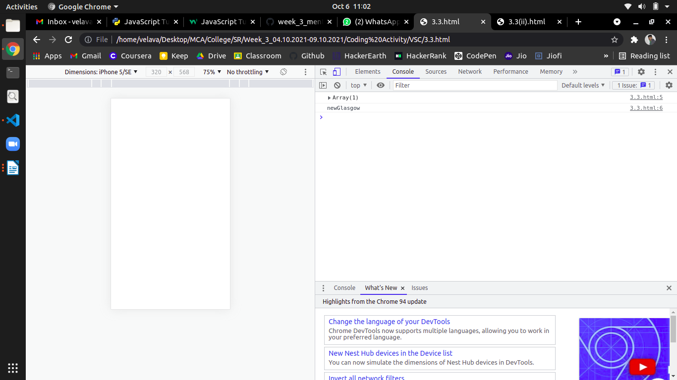

<script>

    function getPlayingStyle()

    {

      var firstTeam=[3,3,1,3];

      var secondTeam= firstTeam;

      secondTeam=[4,1,4,1];

      console.log(firstTeam);

      console.log(secondTeam);

      return secondTeam;}

console.log("results = " + getPlayingStyle());

/////////////////////////

//don't change the code under this line

if (typeof module !== 'undefined') {

  module.exports = getPlayingStyle;

}

</script>

